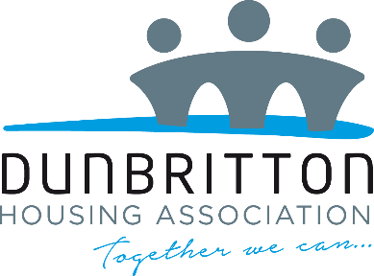

Private & Confidential
Equalities Form

Dunbritton Housing Association is an Equal Opportunities Employer and all applicants for jobs with the Association will receive equal treatment irrespective of age, disability, gender reassignment, marital status, pregnancy & maternity, race, religion & belief, sex or sexual orientation. To help us monitor the effectiveness of the policy on Equal Opportunities, please provide the information requested below.

Please note that this information will not be considered in determining your suitability for the post. It will be kept in strict confidence and will be referred to for statistical purposes only.

This form is removed before the completed application is passed to the recruiting panel.
All questions are optional.

Post Applied For
Where did you see the post advertised/hear about the post?
Do you have a disability (please refer to the definition below)?  Dunbritton Housing Association welcomes applications from disabled candidates and offers a guaranteed interview to those who meet the essential criteria for the vacant post. |  |  |  |  |  | Yes | No
If yes, is it:

Physical? |  | Mental Ill Health? |  |  | Learning Disability?
Visual Impairment? |  | Hearing Impairment? |  |  | Other
Other (please specify):

DISABILITY DEFINITION
Under the Equality Act 2010, a person has a disability if:
- They have a physical or mental impairment
- The impairment has a substantial and long-term adverse effect on their ability to perform normal day-to-day activities

For the purposes of the Act, these words have the following meanings:
- Substantial means more than minor or trivial.
- Long-term means that the effect of the impairment has lasted or is likely to last for at least twelve months.
- Normal day-to-day activities include everyday things like eating, washing, walking and going shopping.

How would you describe your ethnic origin? (Please tick below)

White |  | Asian, Asian Scottish or Asian British |  | Black, Black Scottish or Black British |  | Other Ethnic Background
White Scottish |  | Indian |  | Caribbean |  | Arab
Other British |  | Pakistani |  | African |  | Arab Scottish
Irish |  | Bangladeshi |  | Other Black Background |  | Arab British
Gypsy/Traveller |  | Chinese |  |  |  | Any Other Group
Polish |  | Other Asian Background
Any Other White Background
Mixed or Multiple Ethnic Background

Marital Status - Please tick the option that best relates to you
Single Married Divorced Separated

Civil Partnership Co-habiting Widow/Widower
Gender
Male Female Gender Reassignment

Age - Please tick the age group that best relates to you

16 – 24 35 - 44 55 - 64 75 +

25 - 34 45 - 54 65 - 74

We appreciate that for some people the following questions are very personal. You are under no obligation to answer these questions.

Religion and Belief - Please tick the option that best relates to you

Roman Catholic Muslim Church of Scotland

Atheist/Agnostic (please delete) Other (please specify)
Sexual Orientation
Bi-sexual Heterosexual Homosexual Other (please specify)

